Actividad 06. Medidas de centralidad, detección de comunidades y predicción de enlaces.
- Preparación de grafo social para realizar las pruebas
// Limpiar base de datos
MATCH (n) DETACH DELETE n;

// Crear nodos y relaciones (Basado en fuentes 1 y 2)
CREATE (alice:Person {name: 'Alice'}), (bridget:Person {name: 'Bridget'}),
(charles:Person {name: 'Charles'}), (doug:Person {name: 'Doug'}),
(mark:Person {name: 'Mark'}), (michael:Person {name: 'Michael'}),
(karin:Person {name: 'Karin'}), (chris:Person {name: 'Chris'}),
(will:Person {name: 'Will'}), (zhen:Person {name: 'Zhen'}), (arya:Person {name: 'Arya'}),
(praveena:Person {name: 'Praveena'})

// Relaciones FOLLOWS (Centralidad)
CREATE (alice)-[:FOLLOWS]->(doug), (bridget)-[:FOLLOWS]->(doug),
(charles)-[:FOLLOWS]->(doug), (mark)-[:FOLLOWS]->(doug),
(michael)-[:FOLLOWS]->(doug)

// Relaciones KNOWS (Comunidades)
CREATE (michael)-[:KNOWS]->(karin), (michael)-[:KNOWS]->(alice),
(alice)-[:KNOWS]->(michael), (karin)-[:KNOWS]->(chris),
(will)-[:KNOWS]->(michael), (will)-[:KNOWS]->(mark),
(mark)-[:KNOWS]->(michael), (mark)-[:KNOWS]->(will)

// Relaciones Predicción de Enlaces
CREATE (zhen)-[:FRIENDS]->(praveena), (zhen)-[:FRIENDS]->(michael),
(praveena)-[:FRIENDS]->(michael), (praveena)-[:FRIENDS]->(arya),
(arya)-[:FRIENDS]->(karin), (karin)-[:FRIENDS]->(arya);
  - Proyectar el grafo
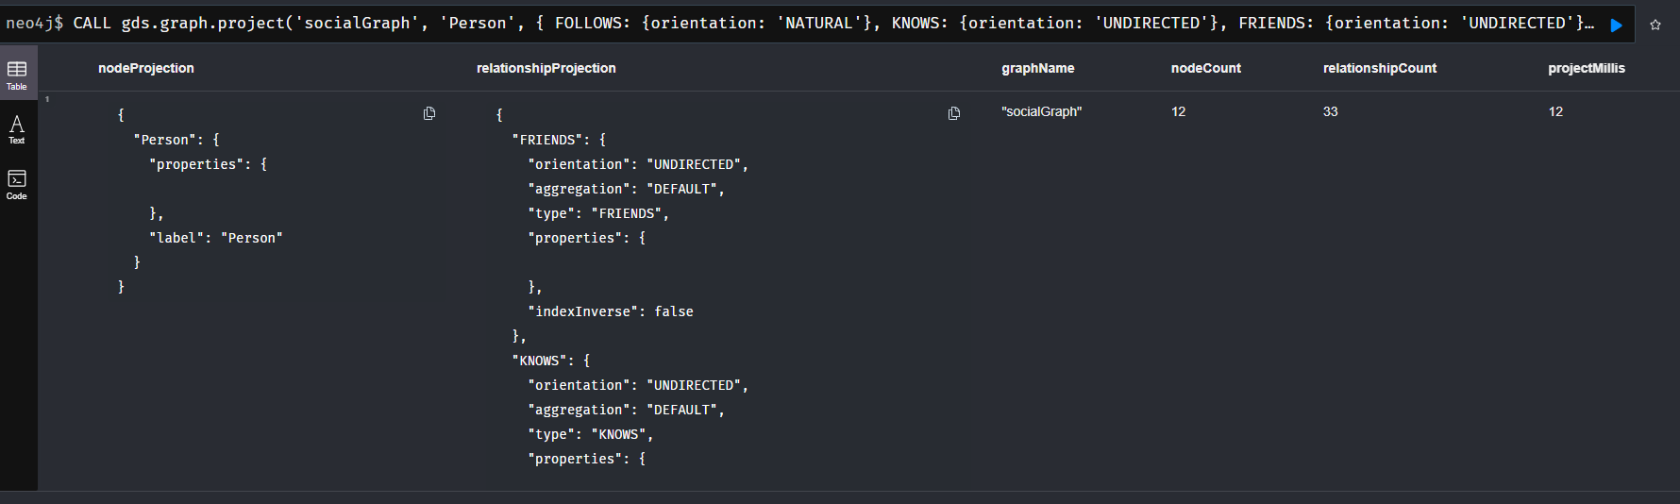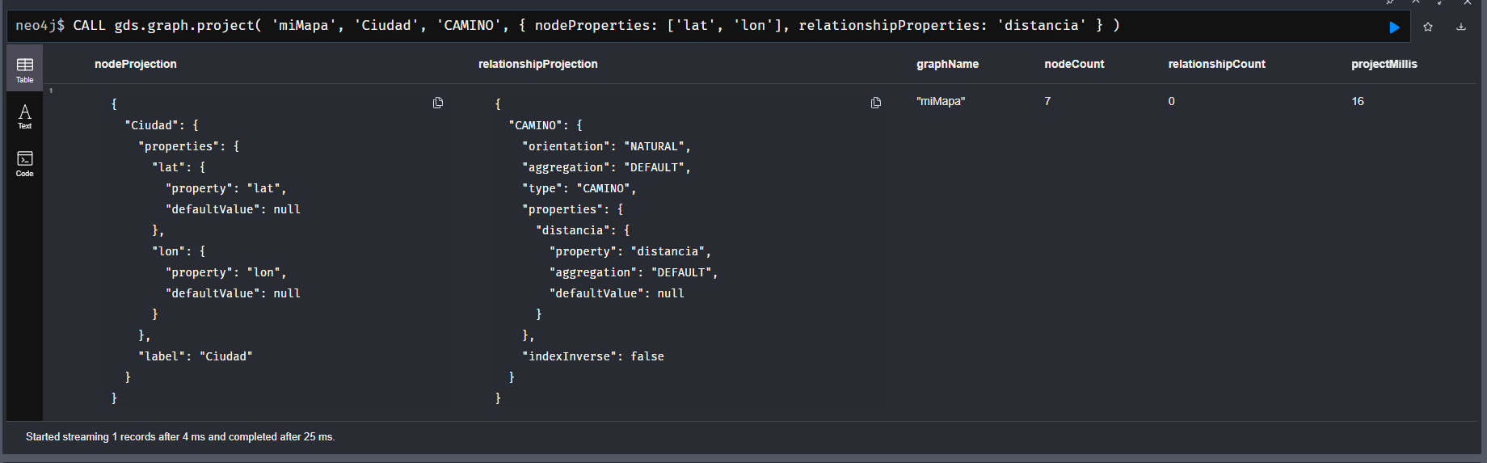
- Medidas de centralidad
  - Grado (Salida)
CALL gds.degree.stream('grafoSocial1', {relationshipTypes: ['FOLLOWS'], orientation: 'NATURAL'})
YIELD nodeId, score RETURN gds.util.asNode(nodeId).name AS Persona, score ORDER BY score DESC;

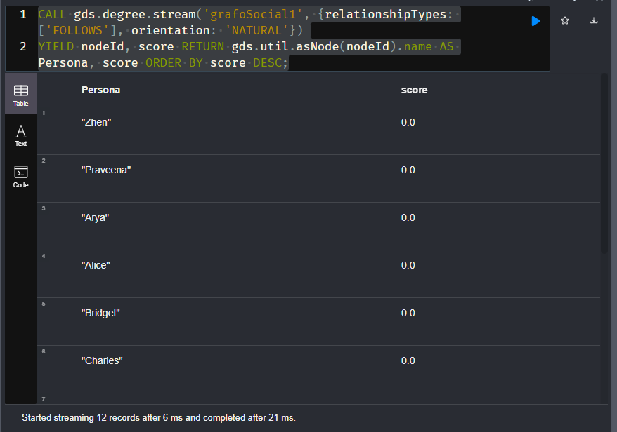
Grado (entrada) CALL gds.degree.stream('grafoSocial2', {relationshipTypes: ['FOLLOWS'], orientation: 'REVERSE'})
YIELD nodeId, score RETURN gds.util.asNode(nodeId).name AS Persona, score ORDER BY score DESC;
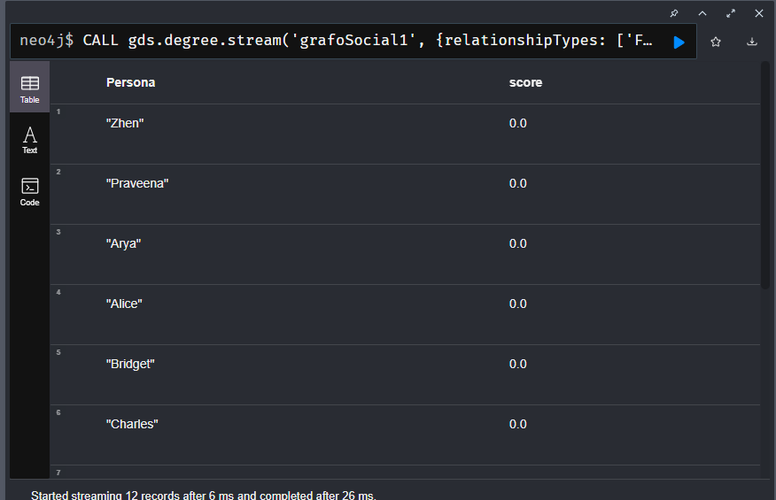
  - Grado (Combinado)
CALL gds.degree.stream('grafoSocial2', {relationshipTypes: ['FOLLOWS'], orientation: 'UNDIRECTED'})
YIELD nodeId, score RETURN gds.util.asNode(nodeId).name AS Persona, score ORDER BY score DESC;
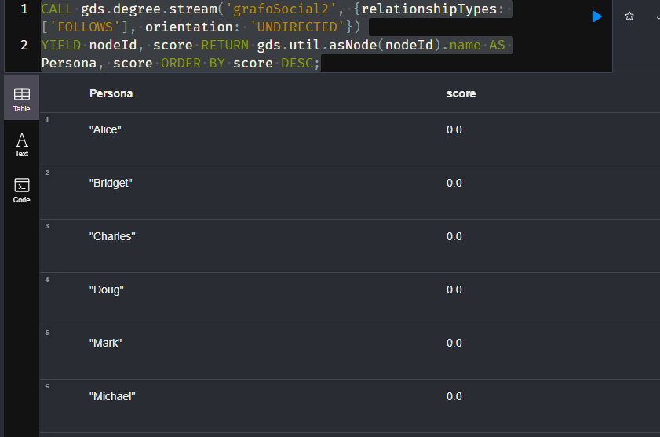
  - Cercanía
CALL gds.beta.closeness.stream('grafoSocial2', {relationshipTypes: ['FOLLOWS']})
YIELD nodeId, score RETURN gds.util.asNode(nodeId).name AS Persona, score ORDER BY score DESC;
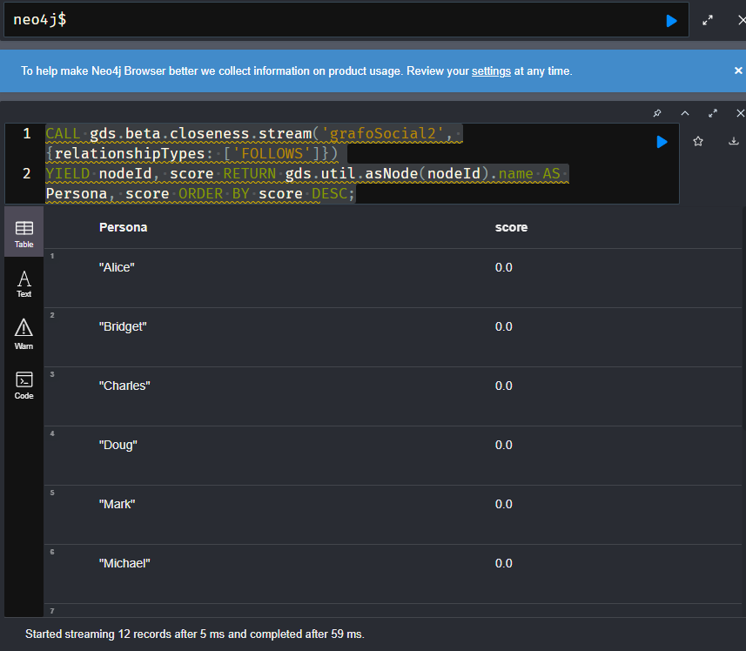
  - Intermediación
CALL gds.betweenness.stream('grafoSocial2', {relationshipTypes: ['FOLLOWS']})
YIELD nodeId, score RETURN gds.util.asNode(nodeId).name AS Persona, score ORDER BY score DESC;
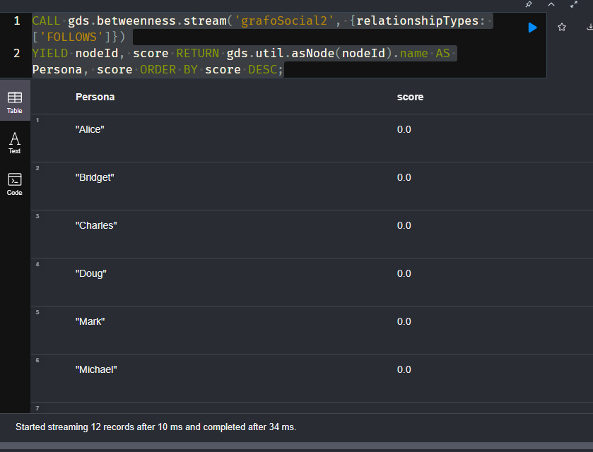
- Detención de comunidades
  - Conteo de Triángulos
CALL gds.triangleCount.stream('grafoSocial2', {relationshipTypes: ['KNOWS']})
YIELD nodeId, triangleCount RETURN gds.util.asNode(nodeId).name AS Persona, triangleCount ORDER BY triangleCount DESC;
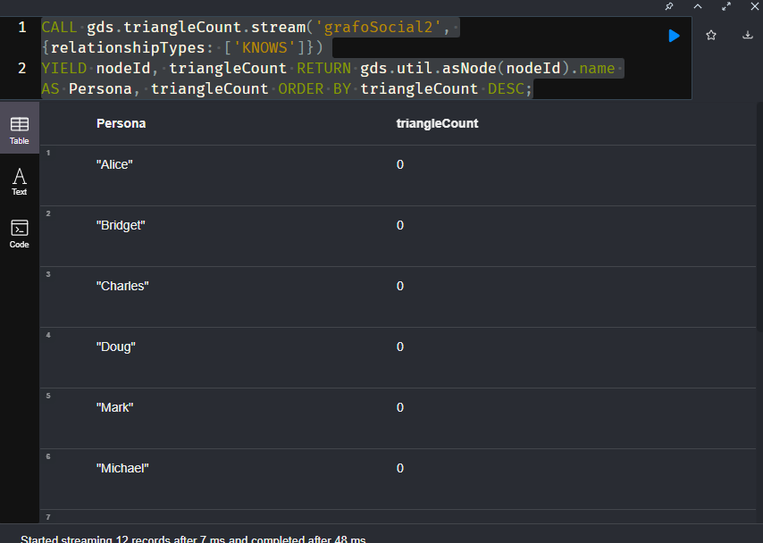
  - Coeficiente Local de Clustering
  - Componenetes Fuertemente conexas
CALL gds.scc.stream('grafoSocial2', {relationshipTypes: ['KNOWS']})
YIELD nodeId, componentId
RETURN gds.util.asNode(nodeId).name AS Persona, componentId;

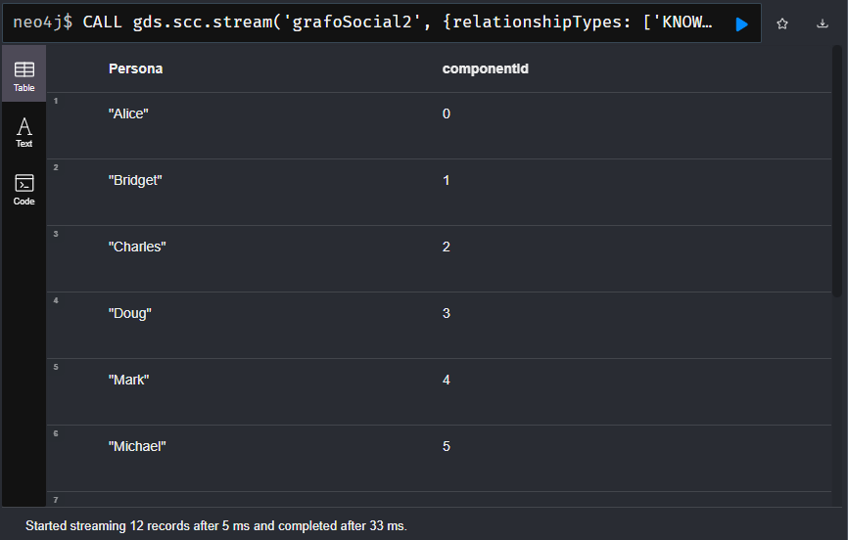
- Predicción de enlaces

MATCH (m:Person {name: 'Michael'}), (k:Person {name: 'Karin'})
RETURN gds.alpha.linkprediction.commonNeighbors(m, k, {relationshipQuery: 'FRIENDS'}) AS Vecinos_Comunes,
gds.alpha.linkprediction.preferentialAttachment(m, k, {relationshipQuery: 'FRIENDS'}) AS Adhesion_Preferencial,
gds.alpha.linkprediction.resourceAllocation(m, k, {relationshipQuery: 'FRIENDS'}) AS Asignacion_Recursos;
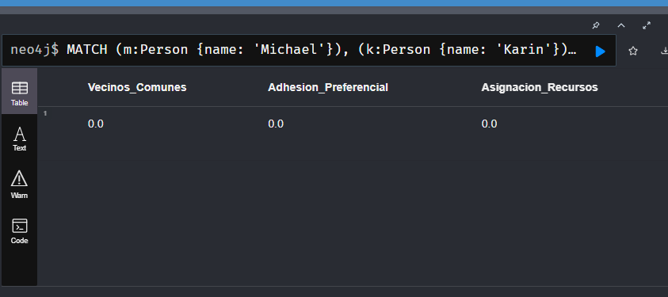
  - Vecinos comunes: El valor es 1, sugiriendo una probabilidad moderada de conexión por tener un amigo compartido.
  - Adherencia Preferencial: El resultado es 6, indicando alta probabilidad de enlace debido a lo bien conectados que están ambos nodos.
  - Asignacion de recursos: El valor de 0.333 mide la cercanía estructural basándose en la importancia de sus vecinos comunes.

